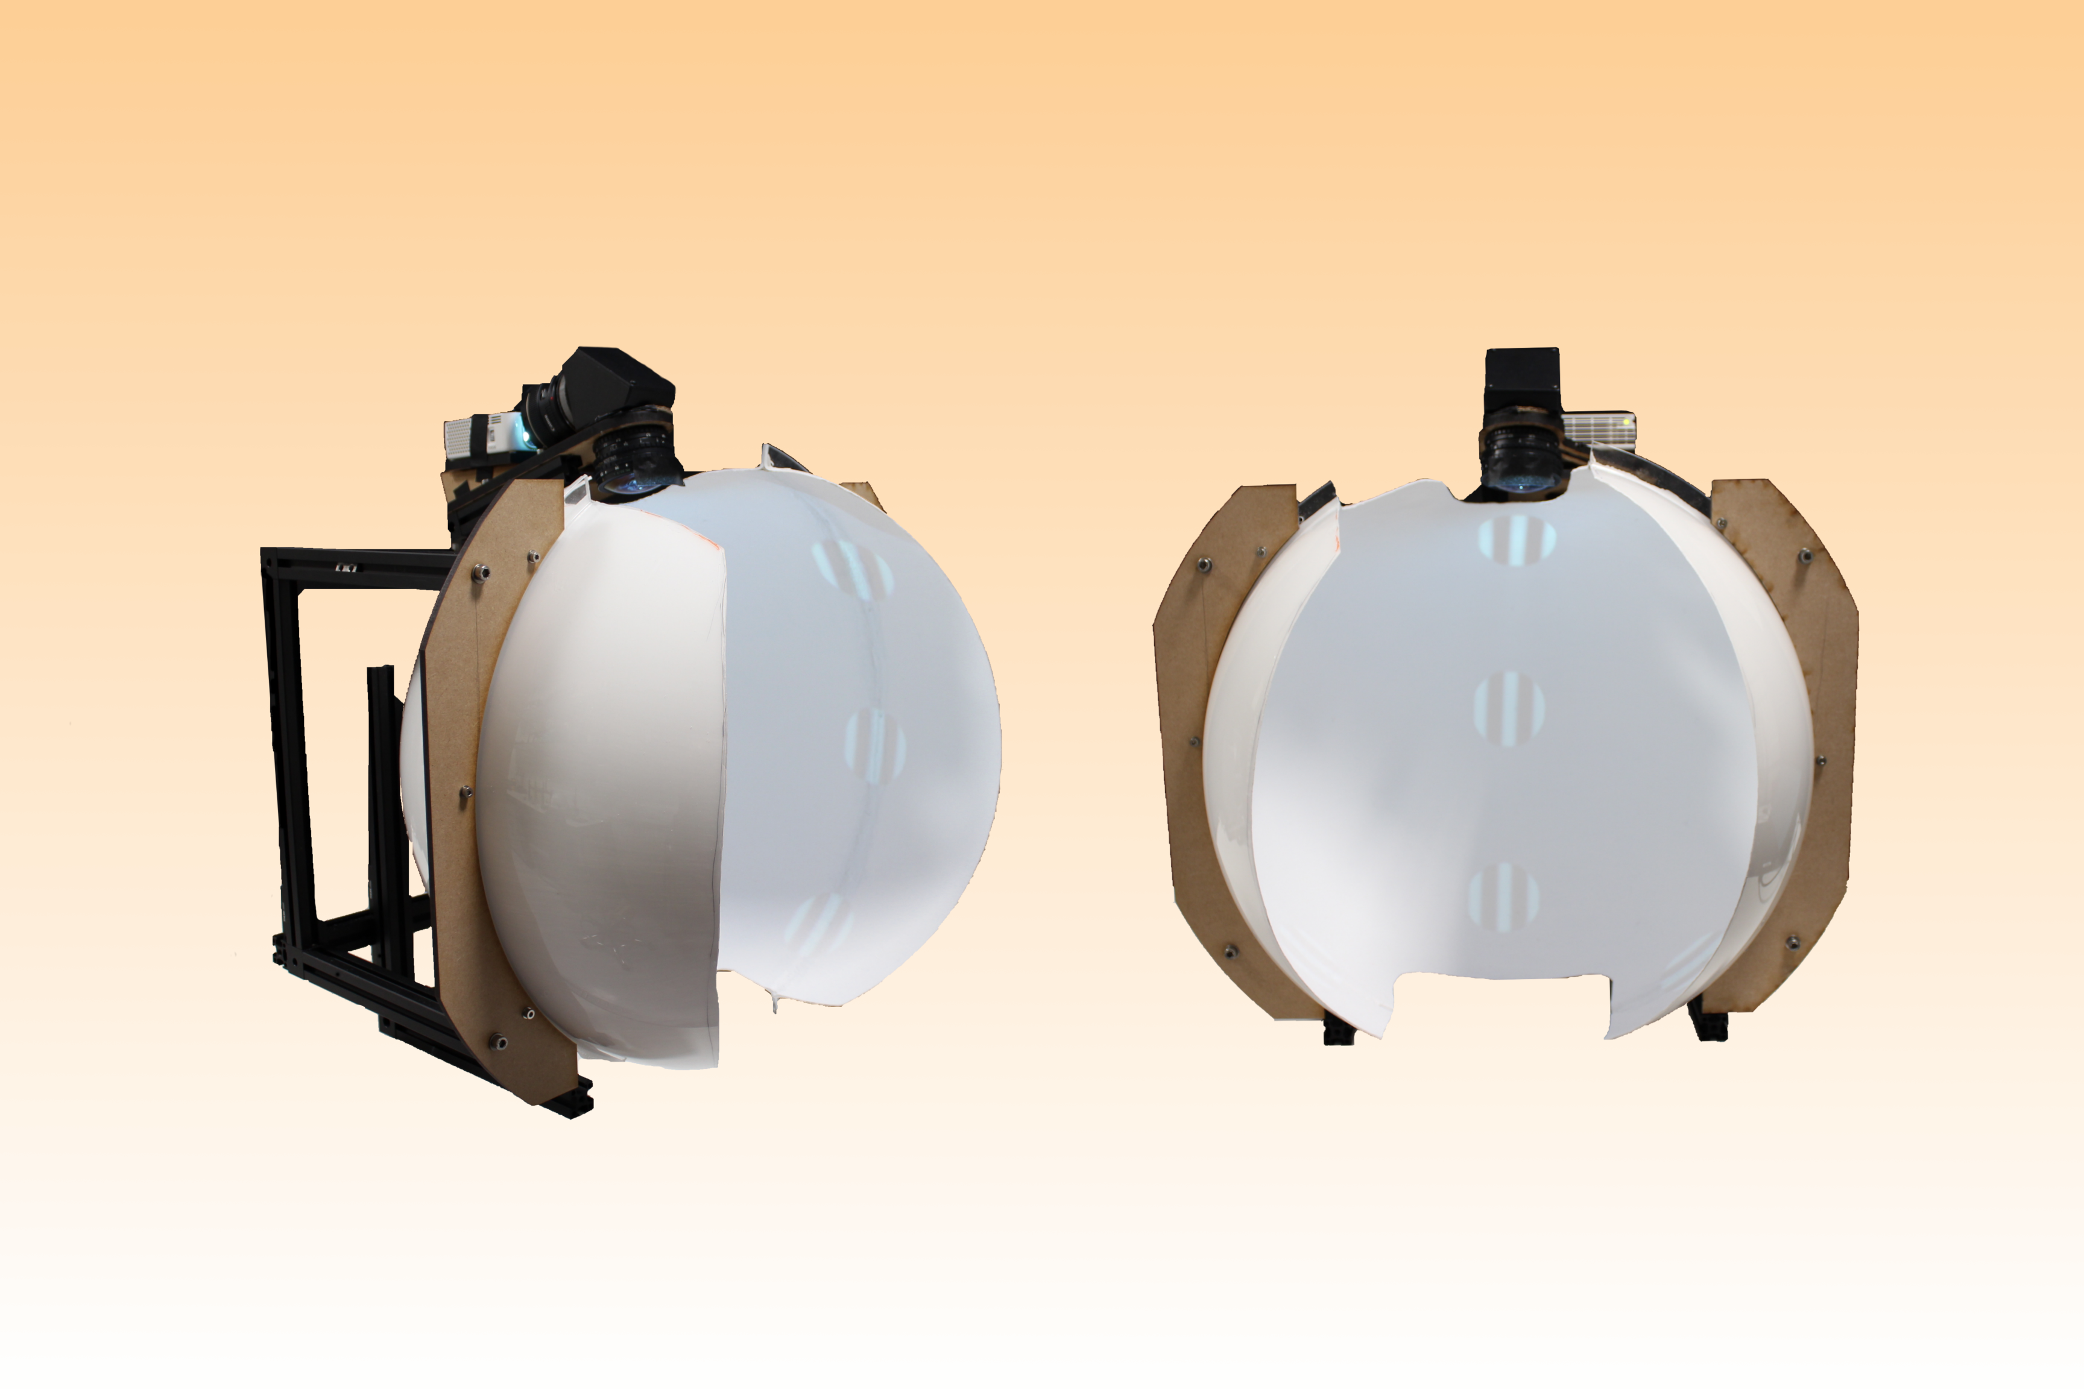Panodisplay User Guide

Table of Contents

In short 4

Aim of the document 4

What it is 4

What it is for 4

How to build 5

Parts list: 5

FabLab Laser Cutting 5

Frame Assembly 5

Applying the Goo 8

Last touch 8

How to calibrate 9

Preliminary settings 9

Calibration pattern and virtual settings 9

General infos 9

Practical 9

Important! Real settings: condenser focal length, projector focus and position 9

How to use 10

Using the projector 10

Navigation 10

With Panda3D 10

Procedural cube and navigation 10

With Unity 11

Visual stimulation 11

Panda3D main classes 11

PanoImage 11

PanoDisplay 12

Stimuli with PyVStim 12

With or without correction 12

Texture presentation 12

Types of stimuli 12

# In short

## Aim of the document

This document aims to quickly enable users to build, calibrate and use the display with either Unity, Panda3D or stand-alone direct visual stimulation.

## What it is

The panoramic display (or panodisplay) allows to cover the full visual field of the subject (e.g. a mouse) placed in the center of it.

It works by projecting an image through a condenser and a fisheye lens.

## What it is for

Typical experiments include visual stimulation and navigation through a virtual environment.

Visual stimulation is done with PyVStim, a PsychoPy wrapper, and navigation is done in Panda3D, a game engine usable with Python (or C++).

# Extra content to help you!

Click the file symbols to open files like videos and parts lists, it will be very helpful.

# How to build

## Parts list



## Dome

### FabLab Laser Cutting

1. Get the Inkscape files "dome_interface" and "projector_plate" (and "projector_holder" as well if you intend to place the projector at the top of the dome, otherwise you will have to use one to project from the bottom).
2. Go to the FabLab and order the following panels of plexiglass (30cmx60cm): 1x 8mm, 1x 6mm.
3. Use the FabLab laser cutter (see annex - you can also ask the FabLab people, they are very helpful!) and cut the "dome_interface" and "projector_plate" each in a 8mm panel, and the "projector_holder" in the 6mm and 3mm panels (yes, twice the same file).

## Frame

* Get the dome acrylic hemispheres.
* Get the Thorlabs parts (see parts list).
* Get your freshly cut parts from the FabLab.

## Step-by-step assembly

Click the .mp4 links for short and detailed assembly videos.

Note: the pictures were taken from an earlier version that used wood instead of plexi.

### Handles (2 of them)

### 2x 225mm rails

### 1x 300mm rail

* + 2x cube
  + 4x M6 black bolt

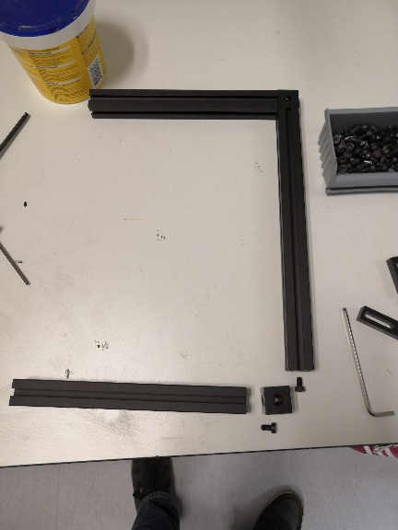

### Projector plate

* + 2x Handles
  + 1x Projector plate
  + 4x M6 bolt
  + 4x M6 washer
  + 4x slide-in bolt

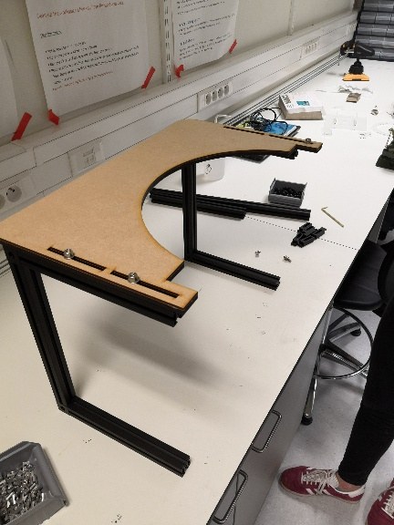

### Interface plates

* + 2x Dome interface plate
  + 2x Acrylic hemisphere
  + 4x M6 bolt
  + 4x M6 washer

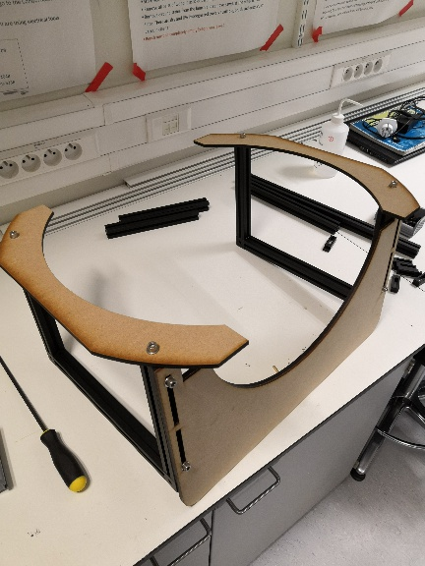 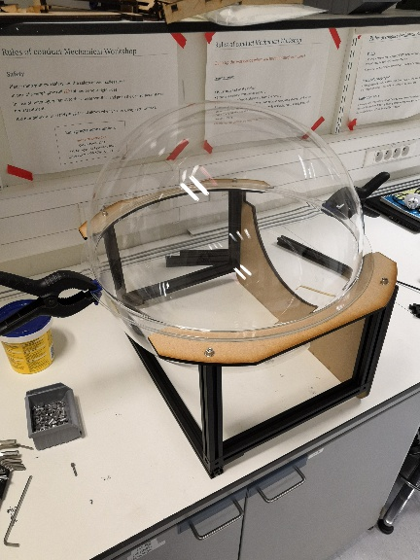

### Drill 3 holes on each side to fit M4 screws

* + 1x drill. Drill thin first, through both hemisphere collars and interface plate, then use 4.5mm. 3 holes per side: bottom, middle, top.

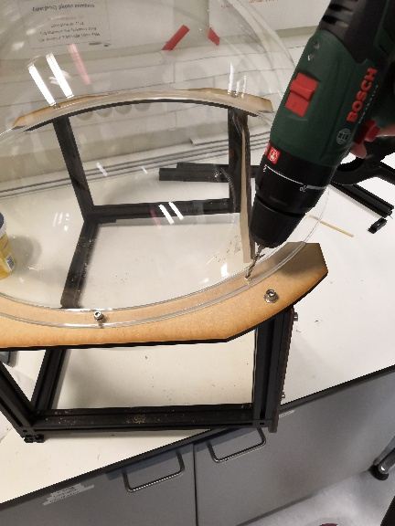

* + 6x M4 bolt
  + 12x M4 washer
  + 6x M4 nut

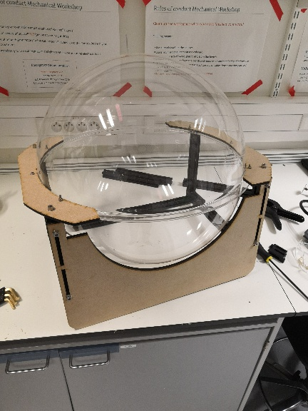

* + Cutout. Use a Dremmel to cut in the hemispheres (mark the cutline with a marker first). The values are given as indications, you might want to do it differently. After the cut, remove the sharp edges with sand paper.

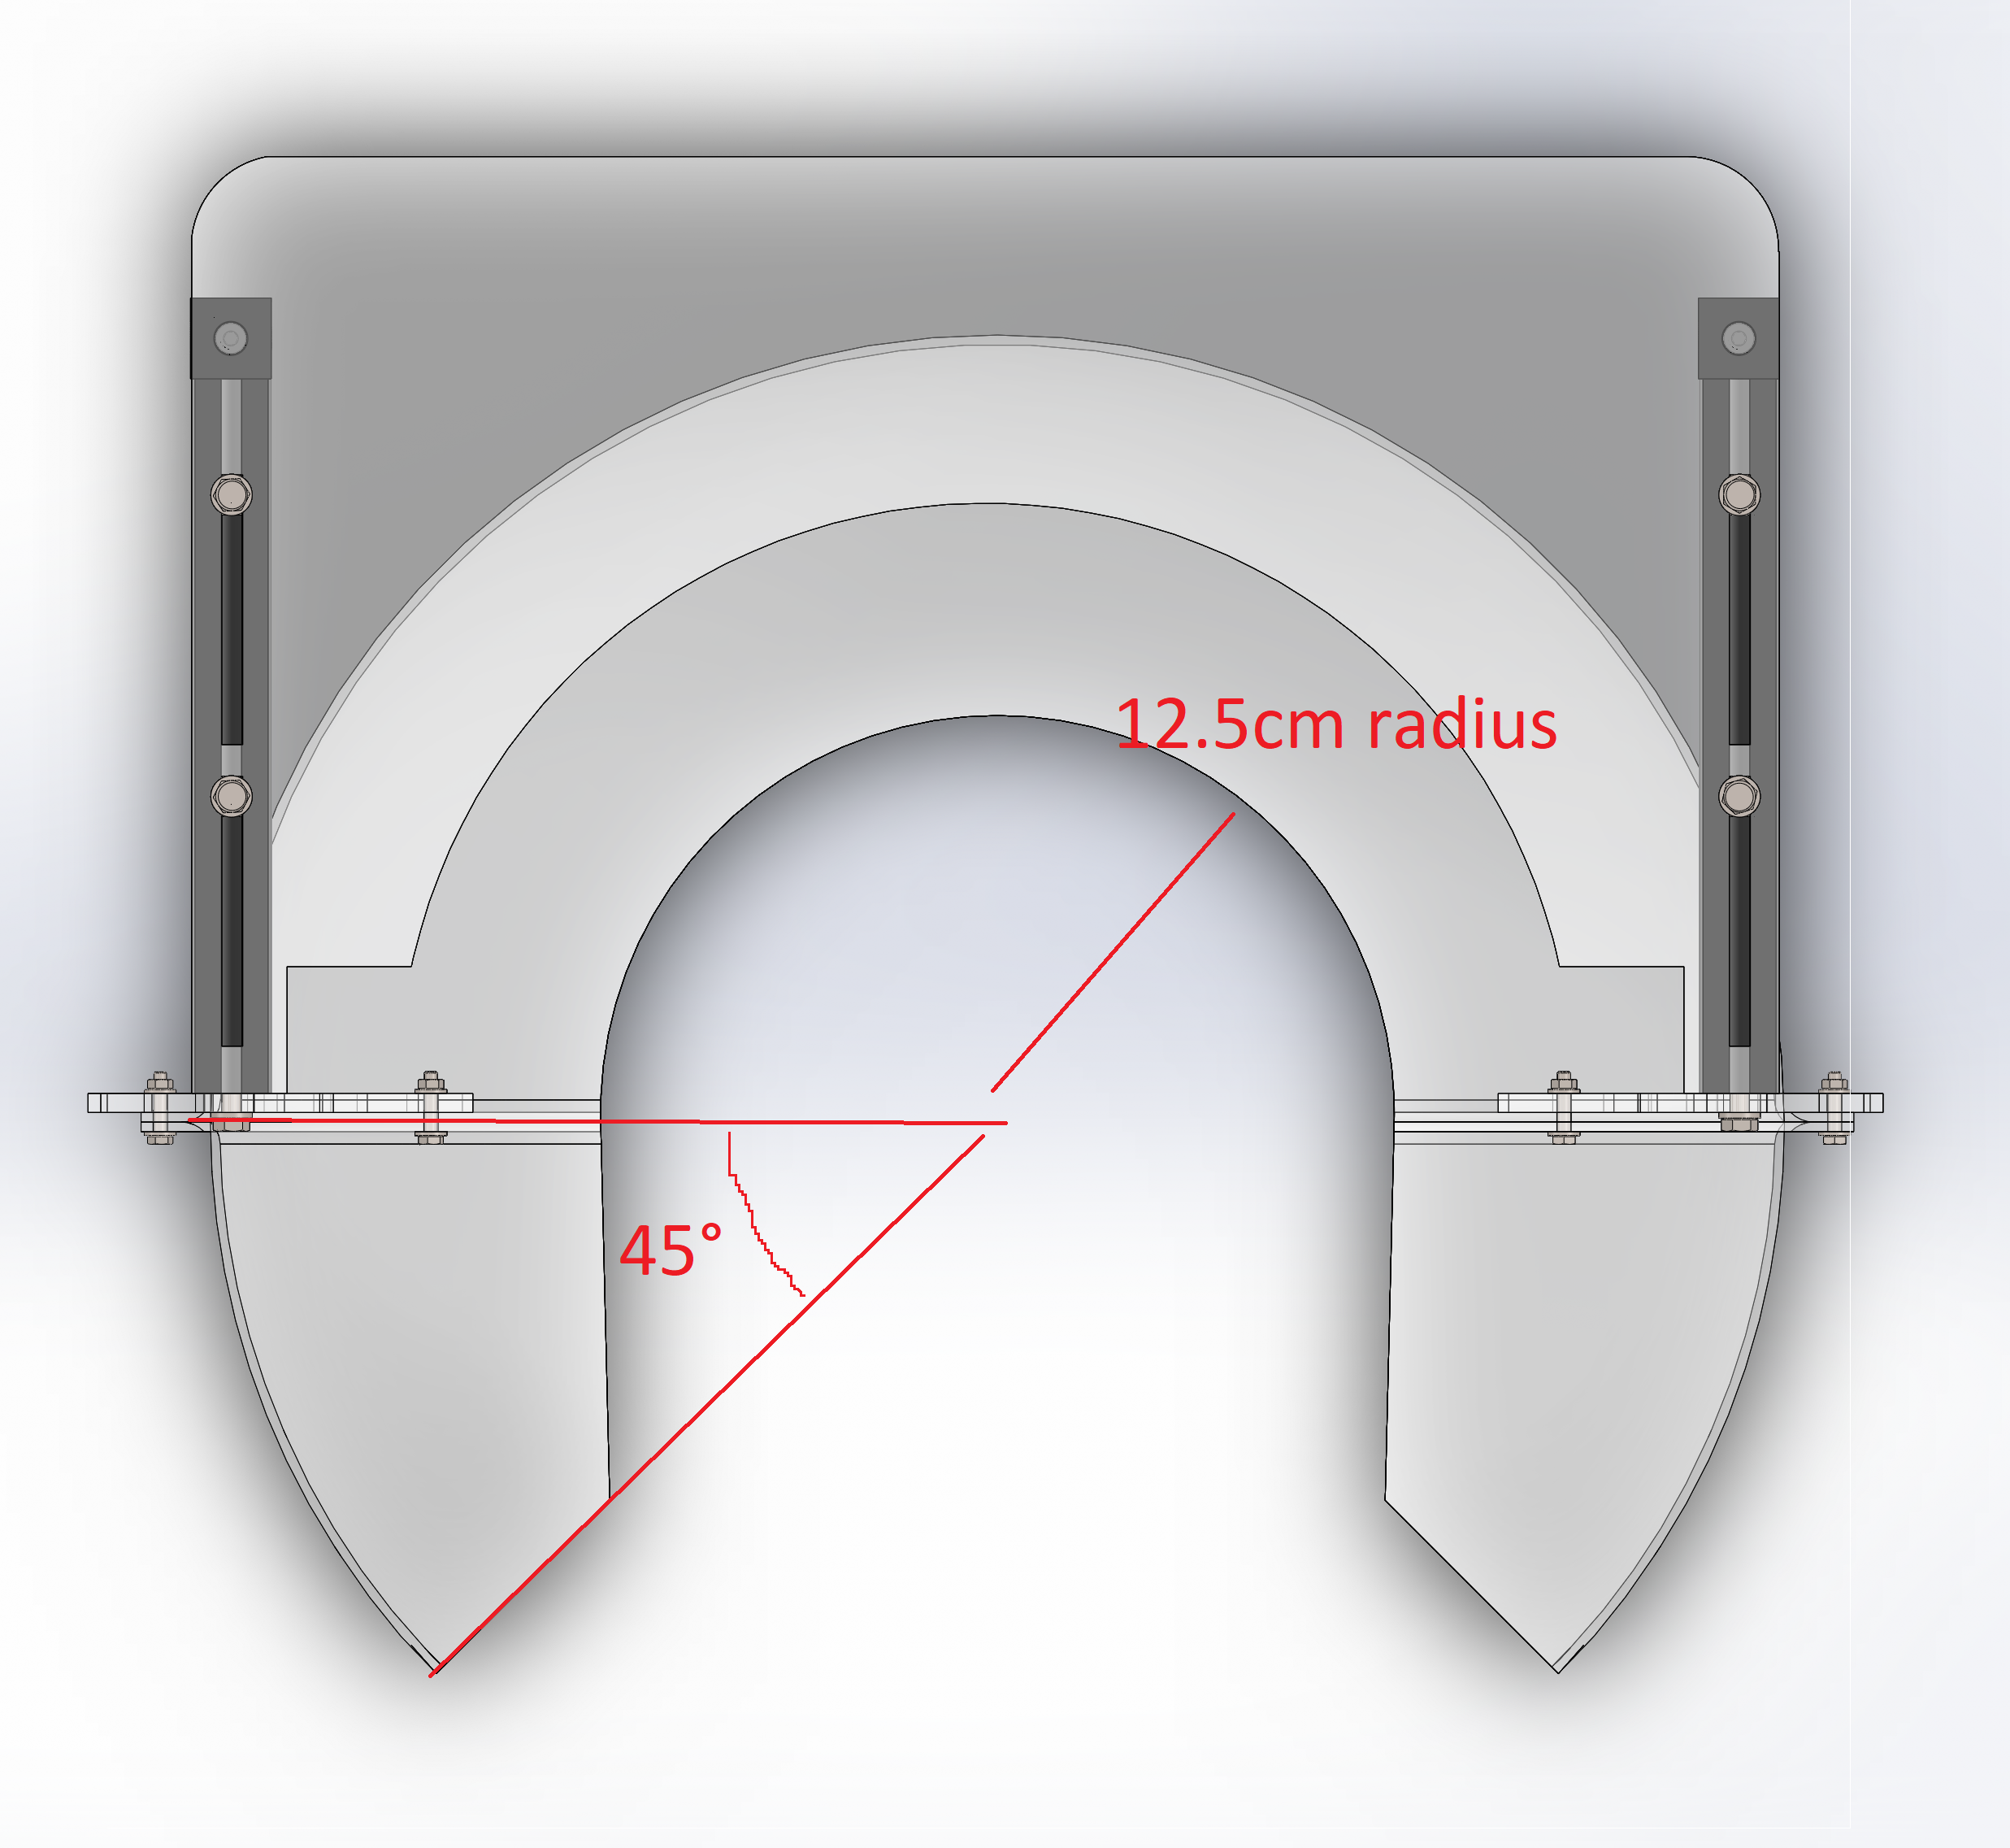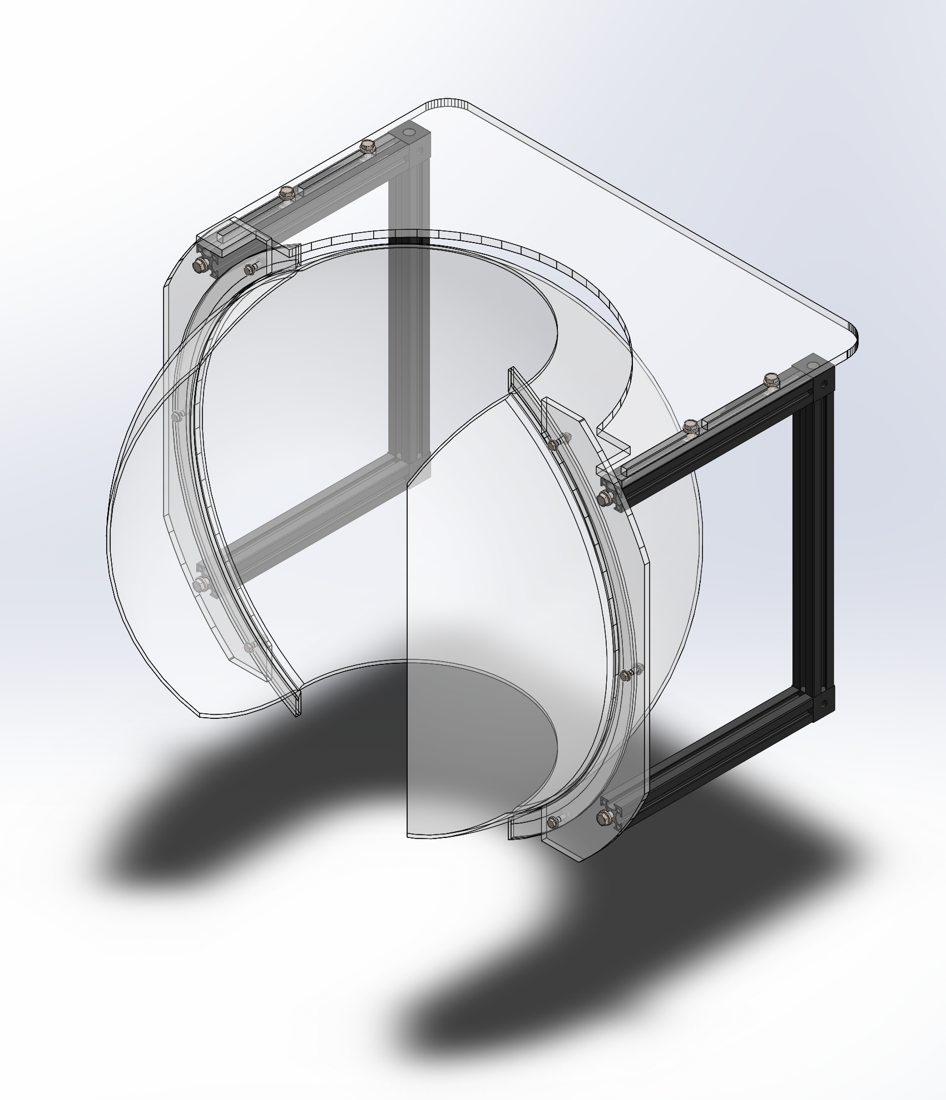

* + 1x 450mm rail
  + 2x M6 black bolt



### Base

* + 1x 375mm rail
  + 2x 300mm rails
  + 4x M6 black bolt



### Putting it all together

Use 4 clamps like this one... to attach the screen to a base

The clamp parts are:

* + 1x XE25CL2 clamp
  + 1x M6 bolt
  + 1x M6 washer
  + 1x M6 slide-in nut

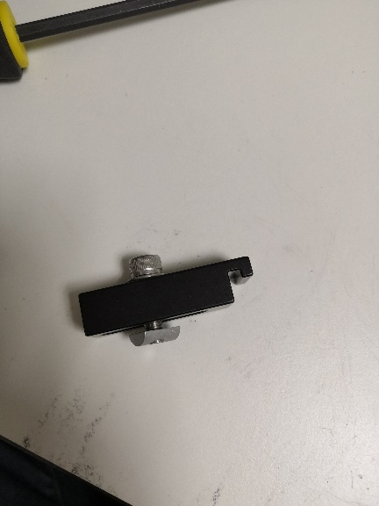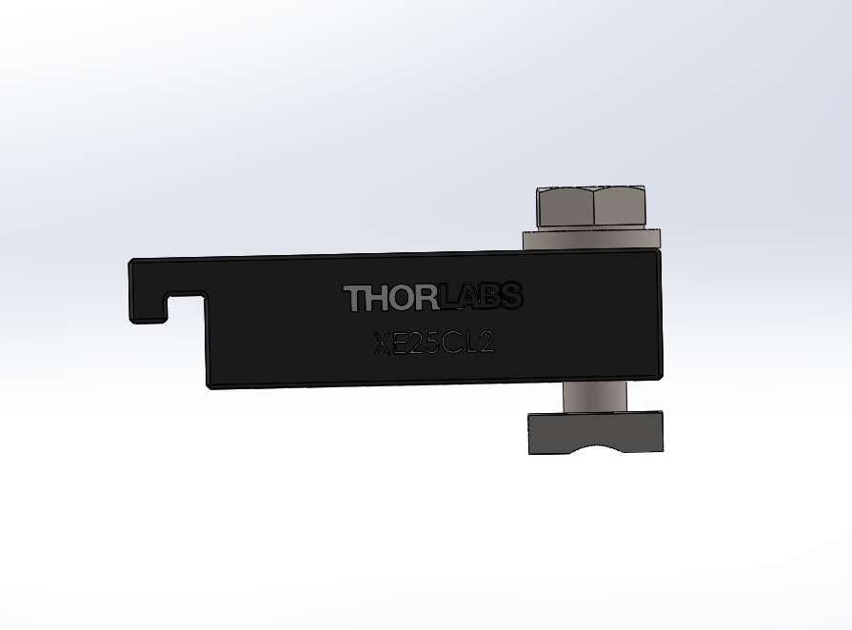

Then place the dome on the base as follows, with 2 clamps up and 2 clamps down.

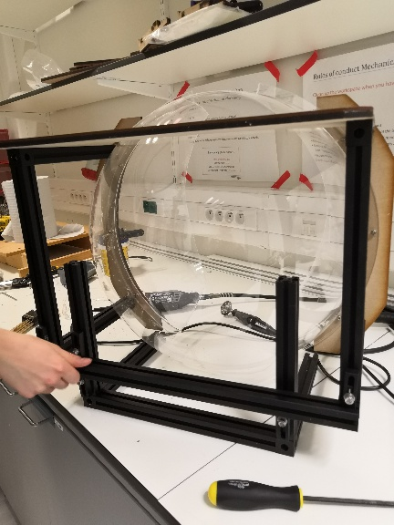

### Some processing

Fill groove between hemispheres with Polyfilla, then remove the excess.

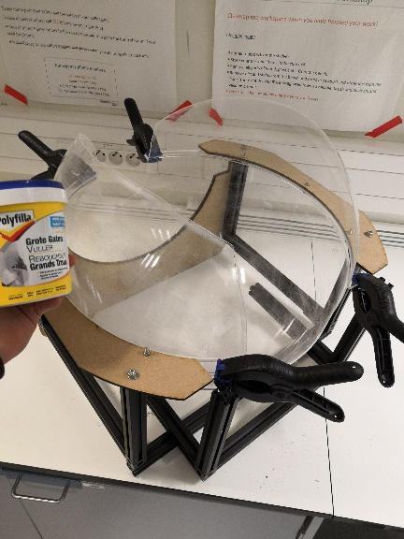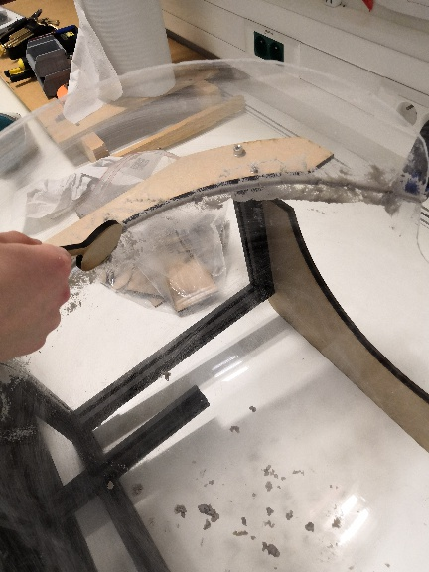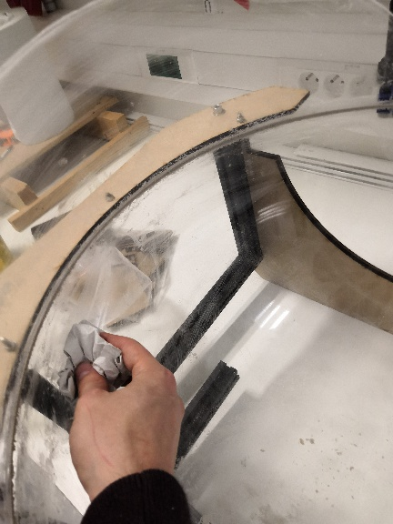

Finally, sandpaper the inside of the screen to increase paint adherence in next step.

## Applying the Goo

The Goo comes in two bottles: primer and finish. Apply 2-3 layers of the primer (wait 2-3h between each layer for the paint to dry) until it looks perfectly even, then apply 2-3 layers of the finish until it looks perfectly even.

We applied it with a sponge to have a uniform texture (brush results in lines and sprayer is near impossible to use on such a small spherical screen).

## The projector holder

The projector holder will be different depending on where you place the fisheye: it can face up or down (it could face the sides too, but that wasn’t necessary so far).

## Last touch

You can add a curtain and tape, ... on the outer side of the screen to block external light and prevent uneven brightness.

# How to calibrate

## Preliminary settings

Fisheye settings:

## Calibration pattern and virtual settings

### General infos

Panda3D is a game engine (like Unity or the Unreal Engine): it allows you, among other things, to place 3D objects in a 3D world, as well as setting up cameras. For visual stimulation, we will simply place a sphere with a camera inside it. A texture is applied to the inner side of the sphere, allowing to control what color is presented for each pixel of the sphere’s texture (the resolution is arbitrary). The camera is a bit special: it uses a cubemap (the environment – here, the sphere – is looked at from 6 different cameras in a cube configuration, covering 360 degrees) that is then projected on a Fisheye Lens (the 6 cubemap textures are remapped to fit on a virtual 360 degrees fisheye).

### Practical

The virtual setup has to be calibrated to match the real one, so that the texture looks the same on the virtual sphere and on the real one. To ensure that it matches, we use the following calibration with our PanoDisplay script (which implements the Panda3D setup).

The goal of the calibration is to have the crossings of the colored lines on the left-middle-right of the screen.

To do that, first we make sure the real projector is well placed: the axis of the fisheye should pass through the center of the sphere.

Then, we can move the virtual rig by changing its position and rotation parameters (the functions are ‘setPos’ and ‘setHpr’), which is done by pressing the following keyboard keys

## Important! Real settings: condenser focal length, projector focus and position

A very important thing to keep in mind is the condenser focal length, which will allow to adjust the throw distance of the projection (changing it will require to adjust the focus of the projector as well to keep a sharp image). This additional degree of freedom is needed to align the pattern.

The position of the projector (in regard to the optical bloc) should be fixed: keep in mind that a slight position change of the projector will induce a big shift in the projection. So ensure that it does not change.

# How to use

## Using the projector

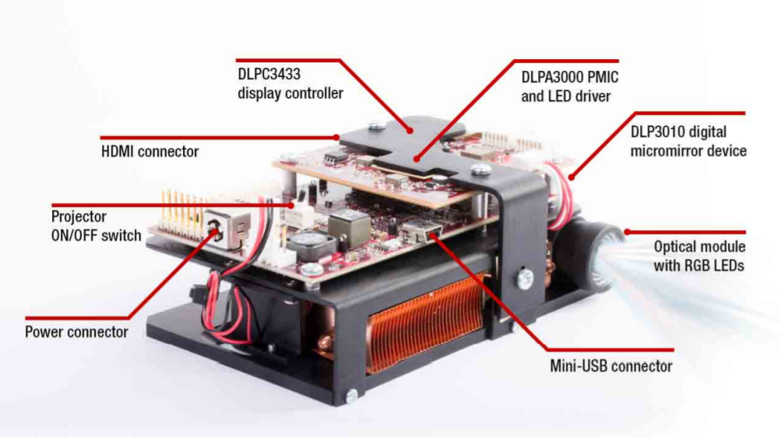

Connect the power connector to a 19V power supply that can deliver at least 2A (the projector can also work with a 12V 5A power supply).

Connect your PC to the mini-HDMI port of the projector to use the display.

If you want to change the firmware settings of the projector, you can connect your PC to the mini-USB port and install the DLP LightCrafter GUI program.



User guide:



## Navigation

### With Panda3D

Panda3D is a full-featured game engine allowing Python (and C++) scripting.

With Panda3D the navigation is launched from a (potentially single) Python script, which allows to have full control and full vision on what happens in an experiment (as opposed to Unity, where it is needed to open the Editor to make modifications, where C# scripts are attached to GameObjects and where interactions are thus ‘hidden’).

Moreover, by default the Panda3D environment is empty (while in Unity there are presets), which makes it more suitable for a controlled experiment.

Finally, the ability to code in Python, and thus the ability to integrate the game code with all the existing Python code for experiment control, makes Panda3D a really sexy alternative.

In this context the only drawbacks of Panda3D, compared to Unity, are its weaker documentation and the somewhat higher coding skills needed to master it.

### Procedural cube and navigation

A simple example to generate an environment with customizable cubes, out of a .json file, is given in the ‘Simple_cube.ipynb’ script. It also contains basic motion controls. Overall it gives a pretty good starting point for a corridor/maze experiment. (Note: it is a variant from the ‘Panodisplay.ipynb’ file.)

### With Unity

Unity is a full-featured game engine allowing C# scripting. The main differences with Panda3D (for us) is that it requires to open the Editor to make modifications to the application, and that the interfacing with the rest of the experiment is slightly less straightforward (it’s not all Python).

It is possible (and relatively easy) to use Unity for experiments with the panodisplay. However, in my experience the optimization did not seem as good as in Panda3D, as it basically crashed my laptop (because of the lack of a proper graphics card; I had to use another machine for development) while in Panda3D I could get 30 to 60 fps depending on the environment displayed. This might have to do with Unity presets (I did not perform any optimization as I only used Unity for proof of concept).

The main advantages of Unity, compared to Panda3D, are its easiness of use and potential continuity with previous workflow.

## Visual stimulation

For visual stimulation where navigation/3D environment are not needed we import the ‘PanoImage.py’ class from the ‘test_panodisplay.ipynb’ notebook to generate the stimuli prior to the experiment (see ‘Moving noise bar’ example). We generate them beforehand for two reasons: first, the script is currently not optimized to run at 60-120Hz (because that workflow might not be the final one, Joao might change it depending on the experiment requirements, which he knows much better than I do); second, it forces you to check the stimuli before presenting them, which I think is a pretty good idea given that the display is still under development.

Once the images are generated we can present them using PyVStim, the PsychoPy wrapper developed by Joao. The advantages of this approach, compared to a Panda3D implementation, is that it allows to have millisecond precision on the presentation of each frame (which is otherwise not trivial on a non-real-time OS), as well as the insurance that none of the frames are skipped for performance reasons (game engines do that).

## Panda3D main classes

### PanoImage

The ‘PanoImage.ipynb’ class allows to create a texture ready to be fitted on a sphere. The coordinates are longitude/latitude. Note that the width of objects has to be adapted to preserve the form of the objects close to the poles (see how the grid converges towards the poles, while the circles do not).

It mainly allows you to place an image on the output texture by specifying the size and position in degrees, and it can (optionally) correct the image so the shape is preserved once applied to the sphere (see the stretched red dots on the canvas).

This class only produces a rectangular texture, the sphere on which it is applied is rendered in the ‘PanoDisplay.ipynb’ class.

See the docstring for more informations.

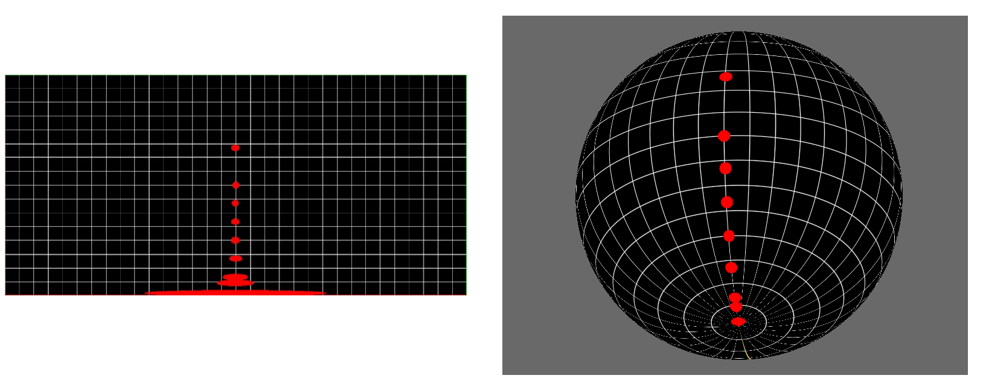

### PanoDisplay

This class contains the basic code blocs to setup a 3D environment compatible with the panodisplay using Panda3D.

Best practice would be to not use it directly but rather use it as a template (see ‘Simple_cube.ipynb’ for a concrete use).

The main blocs are the environment (corridor, inside of a sphere, ... it depends on your experiment), the camera setup (made to replicate a fisheye lens, always the same) and the controls (depend on your experiment).

## Stimuli with PyVStim

### With or without correction

Depending on the stimulus used, you might need correction (stretching around the poles, see above) or not. If the stimulus is a flat texture that you want to apply to the sphere, you probably need to correct. If the stimulus was made in a spherical referential (so it takes into account the decreasing space around the poles), however, the correction is not needed.

### Texture presentation

### Types of stimuli

So far, an horizontal/vertical moving noise bars and a moving noise/gabor have been made.